Blepharoplasty - patient information | - 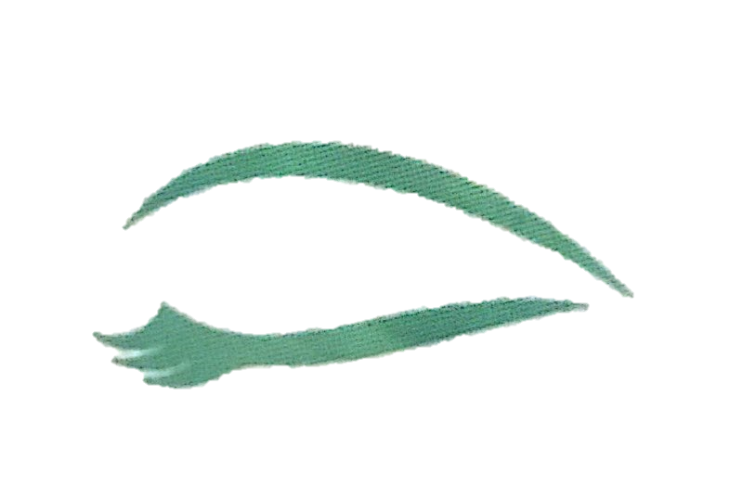www.myeyesurgeon.co.uk
What is blepharoplasty?
This is a surgical procedure to remove excess tissue – skin, muscle and sometimes fat, from the upper and/or lower eyelids. It may be performed in conjunction with other treatment such as a brow lift and botulinum toxin. There are cosmetic and functional reasons for blepharoplasty surgery.
Consultation
You will need to have a consultation with your oculoplastic surgeon, Ms Khandwala She will examine your eyelids and face and ask about your general health and any allergies and medications, especially aspirin and other over the counter tablets, and whether you smoke. You may be required to undergo a general health check by your general practitioner, including heart and blood tests. Your vision will be tested and the health of the eyelids, the tear film and the front of the eyes checked. Your retina may also be checked.
The whole face will be examined and the condition of the skin noted, and the position of the eyebrows and eyelids will be measured. Pre-operative photographs are taken as a baseline for comparison with the results after surgery.
You will be advised whether just the eyelids or the eyebrows too need operating on and whether botulinum toxin injection or other non-surgical treatment is recommended. You will be advised what tablets to stop before the surgery, after consultation with your GP and or cardiologist.
What does the blepharoplasty operation involve?
Removal of excess upper eyelid skin is carried out as day case surgery, generally under local anaesthesia. Occasionally the surgery is performed under local anaesthetic with sedation. You will need to lie flat on your back in the operating room. Anaesthetic drops will be put in your eyes. Your face will be cleaned with antiseptic iodine solution and sterile drapes will be placed around your face. The surgeon will use a pen to mark out the skin to be removed. These cuts are extended a little way into the crow’s feet (also known as laughter lines) at the corner of the eyes. Through these cuts, extra fat, excess skin and possibly sagging muscle are addressed. The ink will wash off later. Anaesthetic is then injected under the eyelid skin, which feels sharp and stings for about ten seconds.Once the area is heavy and numb, the surgery will commence. After this the excess skin is cut away. The fat and or muscle is draped as needed. The skin wounds are then closed with sutures, which will need removal in 1-2 weeks. The wound ends up in the natural skin crease of the lid. At the end of the operation the antiseptic is washed off, ointment is put on the wounds and eye pads applied to the lids. One or both of the eye pads will be removed after about an hour. Occasionally one pad remains in place overnight.
What happens after the operation?
One of your eye pads is usually removed by the ward nurse before you go home. The other is removed by yourself at home the next day.. Do not worry if there is some blood on the eye pad when you remove it. Clean the eyelids gently with tissues soaked in cooled, boiled water. If your eye feels sore when the anaesthetic wears off, take simple painkillers like Paracetamol. Normally, the discomfort will settle within a day or two. It is normal for the eyelids to appear swollen and bruised for some time after this operation and there may be a little bleeding from the eyelids for a short time. Most forms of light exercise and a normal work pattern may be resumed within a few days of surgery. Eyelid makeup can be worn from about three weeks after surgery. If you have SEVERE pain, not relieved by simple painkillers, please ring for advice (see below). You should not drive yourself home after the operation. Before you leave you will be given drops and ointment to use for 2 weeks after the surgery. Eyelids normally heal very well and the wound is hidden in the natural skin crease of the lid.

What to expect after the operation?
Eyelid reductions for the lower lid, or the lower and upper lids, are usually carried out under a general anaesthetic (so you would be asleep). Eyelid reductions for the upper lid only are usually carried out under local anaesthetic. The operation usually takes one or two hours. You might be given antibiotics to keep the wound clean. When you do go home, after a general anaesthetic, a responsible adult should stay with you for the night. Simple painkillers (paracetamol) should be enough to keep you comfortable. After the surgery you should not drive or use machinery for at least 24 hours, until you have recovered feeling, movement and co-ordination. It is common to have watery eyes after an eyelid reduction. This will last a few weeks. Ms Khandwala will prescribe eye drops and ointment to help to ease the feeling of grittiness. After surgery, the eyelids might look and feel tight when closed because of the swelling and because skin has been removed. It is likely, for the first week after upper lid blepharoplasty you may not be able to completely close your eyes at night and use the eye ointment provided before going to sleep. This tightness will ease as the swelling goes down.
What are the possible complications of blepharoplasty?
Bruising and swelling of the eyelids is common. The surface of the eyeball may also swell (chemosis). These changes will settle after a few weeks.
Serious complications are rare but may occur even in the hands of trained and experienced surgeons. Every effort is made to minimize the risk of complications. In the unlikely event of a complication, which can affect your vision, oculoplastic surgeons are trained to manage this. You need to help by stopping aspirin, clopidogrel and non-steroidal anti-inflammatory tablets two weeks before your surgery if your physician or GP will allow this, in order to reduce the risk of bleeding during and after surgery.
- Sunken appearance – a sunken-looking “cadaveric” eye appearance can occur if too much fatty tissue is removed
- Asymmetry – a minimally uneven skin crease or lid height may be noticeable if there is asymmetrical swelling, more marked on one side than the other. If asymmetry is present after two weeks, it may persist and require later secondary surgery
- Scar – rare as the incisions are hidden in the natural skin folds
- Need for repeat surgery – You will have had a detailed discussion with Ms Khandwala prior to signing the consent form about the need for further surgery if an optimum result is not achieved.
- Eyelid and cheek swelling and bruising – May be noticeable for up to 6 weeks
- Blurred vision – For a few hours or overnight, due to surface ocular drying during the procedure, from effect of the local anaesthesia and ointment instilled. If this persists more than 24 hours, inform your oculoplastic surgeon. However please note the ointment prescribed tends to blur your vision.
- Watery eyes – Reflex tearing may occur for 24 – 48 hours due to mild ocular discomfort and surface dryness
- Dry gritty eyes – This may occur for the initial two to three weeks after surgery due to reduced blinking. You will be prescribed artificial tears during the day (e.g. Hypromellose, Systane or Viscotears) and an ointment at night (e.g. Lacrilube or Simple Eye Ointment) to prevent this.
- Scratched surface of the eye – Minor injury to the eye surface can result in pain for 24 hours.
- Bruising behind the eye – Bleeding behind the eye is rare but can cause the eye to go blind.
- Wound infection – This is rare, but can be treated with antibiotics
- Acute glaucoma – Raised pressure within the eye with nausea, vomiting and blurred painful red eye. Specific treatment must be given and review by an ophthalmologist is necessary
- Incomplete eyelid closure – For a few days after surgery the eyelids will feel stiff and not entirely cover the surface of the eye when closed. It usually settles in days – associated discomfort is eased by drops and ointment.

For urgent assistance after discharge, please call the following numbers depending on which hospital you were operated on.
For urgent assistance after discharge, please call the following numbers depending on which hospital you were operated at.
- If you were operated on at Spire Alexandra Hospital- 01634 662843
- If you were operated on at Somerfield Hospital- 01622 208026
- If you were operated on at Nuffield , Tunbridge Wells Hospital- 01892 531111 ext 3369
If you have a routine query after the operation please contact Ms Khandwalas secretary on 01622 238324 or email on myeyesurgeon.co.uk@gmail.com

- If you were operated on at Spire Alexandra Hospital- 01634 662843
- If you were operated on at Somerfield Hospital- 01622
- If you were operated on at Nuffield , Tunbridge Wells Hospital- 01892
If you have a routine query after the operation please contact Michaela Croft on 01622 238324 or email on myeyesurgeon.co.uk@gmail.com

